Player Analytics Group, LLC Launches SpinLucki Slot Tracker to Help Slot Players Track Their Wins, Explore Community Jackpots and Plan Casino Trips
The entertainment and data analytics platform gives players and Slot Influencers access to player-submitted data and analytics not available on any social media platform. Player-reported jackpots, planned bankrolls and trip data power those insights; every membership starts with 90 days free.
FERNANDINA BEACH, Fla., October 14, 2026. Player Analytics Group, LLC today announced the launch of SpinLucki™ Slot Tracker, an entertainment and data analytics platform for slot players and Slot Influencers. Available at spinlucki.com, the platform brings together personal jackpot records, trip planning and searchable community-reported wins. For Slot Influencers, the Creator Studio shows the slot-playing members of their social media audience: where they play, the trips they plan and what they are playing on the casino floor.
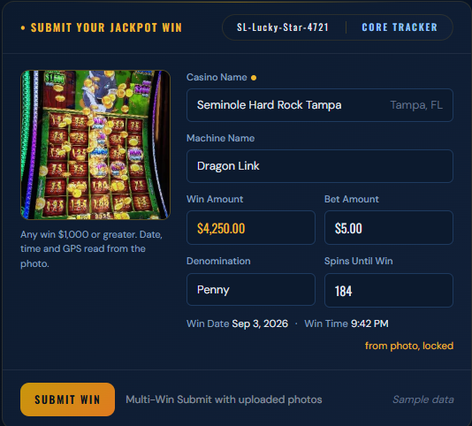
Jackpot photos are not relegated to a camera roll; they become part of players’ jackpot records. SpinLucki Slot Tracker gives that photo moment meaning and utility by adding the casino, machine, date and time, bet, amount won and reported spins before the win. Player Analytics allows players to review their win history by month, by top machines and casinos. High Roller Club members can create a “Make Me an Offer” player proposal that carries their play history across casinos. Players can share it with a casino host at a property where they don’t normally play. The report is the player’s logged jackpot history and estimated player value to start a conversation about a future visit; the casino determines any offer.

“I built SpinLucki Slot Tracker because I wanted more than a camera roll of jackpot photos and a drawer full of tax forms,” said Andy Flick, Founder & Platform Architect of Player Analytics Group. “I believe a community of subscribers reporting their wins brings depth to the data and patterns both players and Slot Influencers can see. Slot Influencers have a new tool to connect with real slot players in their social media audiences.”
The player experience brings together three activities:
- Take a Picture: Build a searchable personal jackpot record instead of leaving the details to memory, scattered photos on a camera roll and paperwork.
- Explore the community: Visualize community-reported jackpots by state, region, casino, machine, day and hour. Heatmaps and a Spins-to-Win graph show when, where and after how many reported spins players hit their jackpots.
- Plan the next trip: Create a Journey Card with a destination, dates and planned bankroll for the next visit.
Slot Influencers get access to SpinLucki Slot Tracker’s Creator Studio. New members choose a Slot Influencer when they join. They see in-app announcements of when and where their Influencer will be playing. Slot Influencers see anonymized player-reported data to inform them where and what to play for their next YouTube video. SpinLucki Slot Tracker’s Casino Partnership Proposal contains anonymized and aggregated player data to substantiate the value of the Slot Influencer’s slot-playing audience, their appearance and compensation.
SpinLucki Slot Tracker proposals distinguish reported records from estimated player value and planned trips from completed attendance. SpinLucki Slot Tracker describes; it does not predict. At launch, community views include clearly labeled sample data so new members can explore how the platform works. Sample data can be turned off at any time.
SpinLucki Slot Tracker maintains casino, slot-title and Slot Influencer registries. Companion resources include slot-machine education at slottracker.ai and The Spin, a publication covering the Slot Influencer community.
The platform’s community data is anonymized with no names, contact details or player card numbers. Its records reflect member-reported wins. It does not facilitate gambling or predict slot outcomes. It is an established fact that the math in a slot machine cannot be beaten. SpinLucki Slot Tracker gives players and Slot Influencers insights they don’t have.
Availability
SpinLucki Slot Tracker is available at spinlucki.com. Every membership starts with 90 days free; annual membership plans are Core Tracker at $81, Influencer Connect at $135 and High Roller Club at $261.
About SpinLucki Slot Tracker
SpinLucki Slot Tracker is an entertainment and data analytics platform operated by Player Analytics Group, LLC of Fernandina Beach, Florida. It gives slot players a tool to keep their jackpot records, explore community-reported wins and plan trips, while giving Slot Influencers a player-reported foundation for casino partnership conversations.
Media contact
Kristina Flick
Vice President, Brand and Player Education
Player Analytics Group, LLC
press@spinlucki.com
+1 904-206-8918
spinlucki.com

